PARKING TRACKING SYSTEM

Students : Leyla BAYKALI / Cansu CEYLAN

IDs : 21287285690 / 12913007014

Semester : Fall 2020

ABSTRACT

Nowadays, with the increase of personal vehicles used, the difficulty of drivers in finding parking spaces is increasing. The fact that they are more mobile to find a parking space increases fuel consumption, traffic density, environmental pollution and loss of time. The aim of this project is to identify empty parking spaces in parking areas and direct drivers to these areas. The parking lot will be regularly recorded and empty spaces will be determined by image processing method. In this way, drivers will be able to see the vacancy rate in the car parks they enter and determine their route accordingly.

KEYWORDS

Image processing, parking detection, video analysis, smart parking systems

INTRODUCTION

With the increase in population, private vehicles are increasing day by day, especially in big cities, and it is difficult to find parking spaces. People keep traffic busy searching for parking spaces, and heavy traffic causes tension and stress. Some studies found that Americans spent an average of 17 hours per person a year searching for parking, with fuel and emissions losses of about $ 345. This means an annual loss of about 73 million dollars. People have used a variety of methods to solve the parking problem that caused this and many other challenges. Some of these are sensors. Sensors and methods have been developed to show the availability of parking spaces, but these sensors, which must be placed in the area reserved for each vehicle, are very costly for high-capacity parking lots. Another system that can be developed for this is the camera and image processing system. Today, cameras are used almost everywhere for security reasons. These cameras, which are currently used, provide full control of the parking lot. Thanks to image processing technology, photographs, video or live images taken from cameras are processed and objects or empty areas are detected. There are many ways to use this technology. One of them is the detection of objects, namely the tracking of incoming and outgoing vehicles in this project and the detection made depending on the movement of the vehicle. Another is the determination based on whether there is an object, ie a vehicle, in the area. In this project, we aim to determine whether the area is occupied by processing video images taken from a camera that dominates the entire parking lot. We aim to enable drivers to see the occupancy status of the parking lot by projecting the data we have obtained on a digital screen.

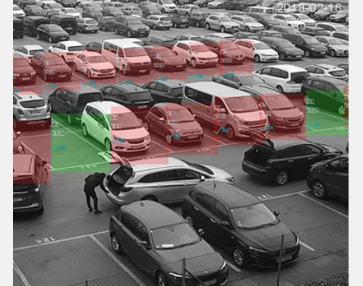

Figure 1: Determination of parking spots

CHALLENGES IN THE IMAGE PROCESSING METHOD

Real Time Operation

Although the correct detection of the occupancy of the parking spaces is thought to be sufficient for the system to work, the processing times must be short in order for these systems to be used in real life. In this way, information on whether the parking spaces are full or empty can be tracked in real time without delay.

Camera Selection

Some researchers have preferred to use the images taken from the security cameras available in observing the parking lots. In this way, the cost was aimed to be minimized because the existing camera system was used. In many studies, images obtained from security cameras were transferred to a server over the internet and image processing algorithms were run on these images. Various problems arise when using this method. The images of security cameras are generally low quality and black and white. Since these images are processed, quality is compromised, so the vehicles in places that are not clearly visible cannot be determined properly. It has been stated in the research that color images give higher accuracy results on this subject. As the size of the parking lot increases, the number of cameras that need to be used will increase, transferring large amounts of image data over the internet may cause problems in terms of network capacity.

Areas That Cameras Cannot See

Some areas in the images in front of trees, poles, etc. As there are obstacles, determining the status of the parking spaces in places with limited or no view poses a problem. In some studies, a solution to the problem was sought by using the image of the camera with the best view of the relevant area from more than one camera image viewing the same parking lot. However, this method cannot produce a solution for a parking area.

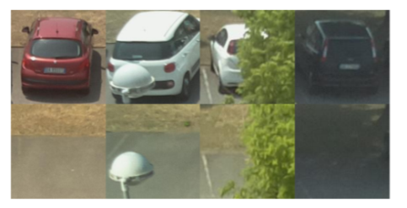

Figure 2: Areas That Cameras Cannot See

Changing Light Conditions

Studies have been conducted on images taken under different weather conditions. However, these images are generally taken into account in cloudy and rainy weather. When it is night, it may be almost impossible to process the images taken from the cameras due to the dark environment. In this case, cameras that give better results in the dark may need to be used, which can increase the cost.

General Application of Algorithms

It is controversial that the systems developed can work with similar performance rates in images from other parking areas. It should be investigated whether the algorithms developed on the basis of a data set are suitable for processing images collected from different parking lots.

MATERIAL AND METHOD

Various image processing methods are used to detect whether there is a vehicle in the determined image units. With the background subtraction technique, it was aimed to obtain the reference required to distinguish between moving and stationary objects. After the background is revealed, a temporary map is generated so that vehicles can be identified and followed in the image. In this way, the vehicles entering and leaving the parking lot are determined and the information whether the parking spaces are empty or full is revealed.

There are also studies using the corner detection technique to detect vehicles in images. With this technique, the shapes that provide the physical properties of the vehicles are searched within the image. The negative effect of light on the image is removed by changing the color space of the image part to be examined. When Table 1 is examined, the methods proposed have achieved very high success rates. However, while conducting the research whose results are presented, each made certain assumptions and used separate data sets. Therefore, it is thought that there are deficiencies in applying the suggested methods directly to real life scenarios. These shortcomings and challenges are discussed below.

PROPOSED METHOD

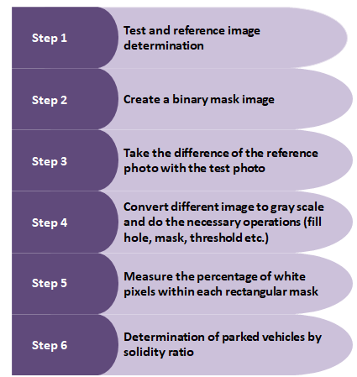

Figure 3: Steps of project methods

Step 1:

We took the bird's eye view of the parking lot of the car park as a test image. We determined the empty state of the same parking space as the reference image.

Step 2:

We determined the parking areas with rectangular shapes on the reference image and we turned this image into binary.

Step 3:

We extracted the reference image from the test image to detect filled areas. And the remaining different image shows our vehicles in the parking lot in rgb form.

Step 4:

We converted the difference image we obtained to grayscale and then masked it with a space mask.

We took a histogram from this image and detected areas in the image. We thresholded the image to find pixels that are very different from the background. We filled the holes in the resulting image and got a convex body.

Step 5:

We measured the percentages of white pixels within each rectangular mask and checked that it meets these properties (features: MeanIntensity, Centroid, BoundingBox)

Step 6:

Finally, we examined the status of the parking area according to the solidity ratio in the specified regions. We have set a limiting rate so that it does not detect objects (people, animals, etc.) other than engines and vehicles in the parking area. We set this ratio as 0.13. And we created a project that only detects vehicles and engines and shows the parking situation accordingly.

EXPERIMENT RESULTS

We aimed to create a data set that includes common situations in our experiments. We did tests for situations where there might be errors in image processing in the parking lot and we got some results. According to these results, images (people, animals, etc.) other than the parked vehicle should not affect the condition of the parking area. Various examples and results for this are shown below

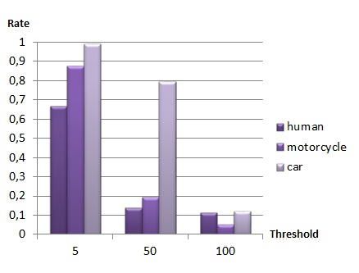

Graph 1: Solidity ratio comparance

In the graph, solidity ratios of three different objects are given according to the changing threshold values. As can be seen, if the threshold value is higher or lower than necessary, errors in solidity ratio increase. If the threshold value is low, empty parking spaces appear to be full as a result of the increase of white pixels. If the threshold value is high, parking spaces that are filled as a result of the decrease of white pixels also appear empty.

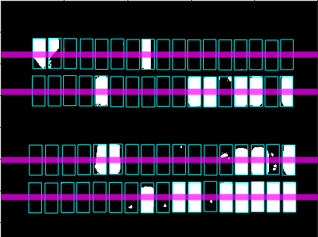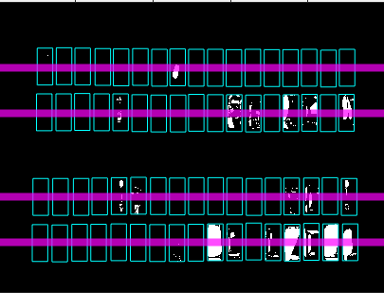

Figure 4: Low threshold / High threshold

While determining the occupancy rate of the park, we set a threshold at the upper level of the occupancy rate of the human image so that it can detect the motorbike or the car instead of detecting the person.

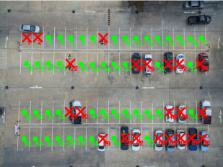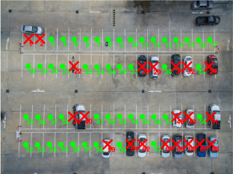

Figure 5: Not accepting the human image

We examined the errors that occurred in the experiment result of wrong parking. As a result, we observed that the vehicles showed one or more parking areas as occupied as a result of not being parked correctly.

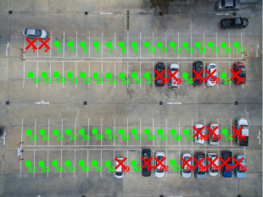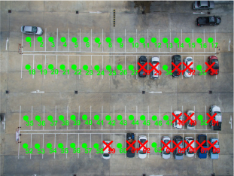 Figure 6: Wrong parking

SUMMARY/COMMENTS

As a result, in this project, we aimed to create a solution to the parking problem, which has become a significant problem today. We determined the number of vehicles parked in the parking lot by detecting the differences between the images taken one after another. While doing this project, we made use of image processing methods such as threshold, masking, filling hole, gray scale, histogram. We determined the empty state of the parking lot as a reference photo and we observed the number of vehicles parked in the parking lot, taking the difference between the images taken at other times(test images). We added people, motorcycles and incorrectly parked vehicles to our test photo to see our error rates. We have made the necessary adjustments to prevent people from appearing as a tool. Finally, we completed our project that detects the motorcycles and vehicles in park and shows the solidity ratio of the parking lot. We aim to reduce the time, fuel and stress caused by this project due to the parking lot.

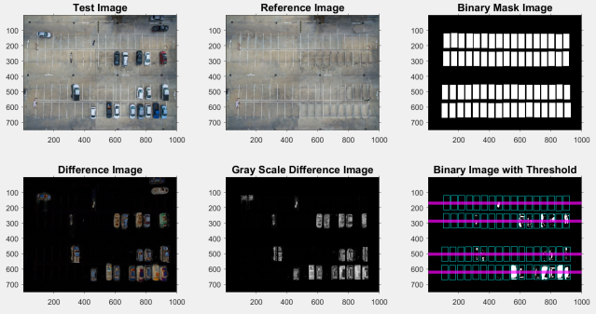

Figure 7: Result of project



Figure 8: Output image

REFERENCES

[1] **Inrix,** “Searching for Parking Costs Americans $73 Billion a Year.”

[2] **Mehmet Serdar Güzel** Versatile Vehicle Tracking and Counting Application

[3] **Fatih Can Akıncı , Murat Karakaya** Şehirlerin Dijital Dönüşümü: Görüntü İşleme Yöntemlerinin Boş Park Yerlerinin Tespitinde Kullanılması

[4] **Zeynel Baran YILDIRIM1 , Bekir Eray ÖZDEMİR , Ezgi EREN** Trafikteki Araç Sayımlarının Farklı Görüntü İşleme Teknikleri Kullanılarak Karşılaştırılması

[5] **Tanapat Xu, Wutichai Chansawat Phisan Kaewprapha** Car Parking Space Detection System

[6] **Lin Zhang ID , Xiyuan Li, Junhao Huang, Ying Shen and Dongqing Wang** Vision-Based Parking-Slot Detection: A Benchmark and A Learning-Based Approach